**Preliminary report on sample size considerations for the BTB DIVA test trial.**

**Summary**

* We recommend to test 1000 certified negative animals (with status known from the results of a gold standard approach and/or from animals in a region known to be disease free), in order to have a solid indication that the test is >99.7% specific, before the rest of the trial is conducted.
* For the objective of being able to prove that the DIVA test has a >99.85% specificity at a 95% significance level,, using a latent class analysis, we recommend that the trial include no less than 50 000 animals over the five years (this is under 80% power). These animals should come from two different populations with different expected BTB incidence, ideally in a 50/50 ratio.
* If one instead is satisfied with an objective of getting an estimate of the specificity with a 95% credible interval that it lies within [99.8,99.999]%, it would be enough to include YYYY animals in the trial.
* If it is not feasible to find animals from two populations with different BTB incidences, it is possible to treat the vaccinated animals as a low-prevalence cohort, but only if it is possible to assume a priori that specificity is the same for vaccinated and non-vaccinated animals.
* The sample size required is crucially dependent on the true specificity of the DIVA test. A true specificity of 99.9% (One false positive in 1000 tests) means that a ten times larger trial would be needed that if the specificity is 99.99% ( One false positive in 10 000 tests).

Results

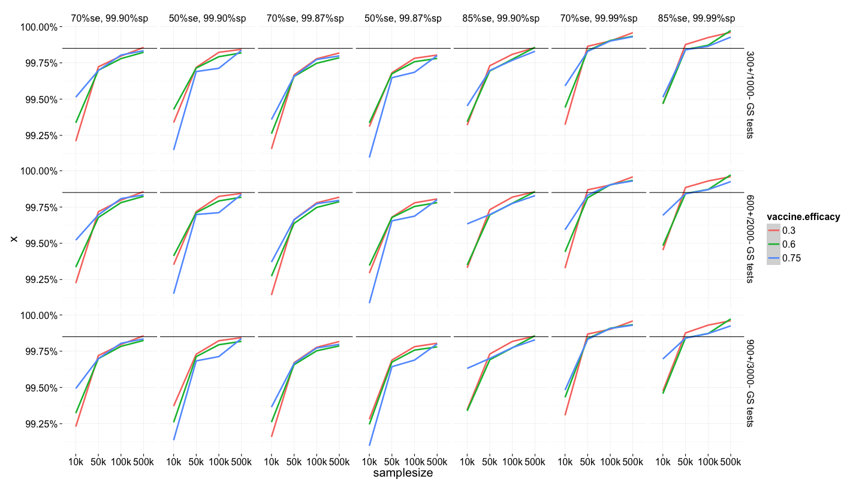

Figure1. The graph shows the effect of different parameters on the lower bound of test specificity that the trial would be able to demonstrate. The black line indicates the 99.85% specificity threshold. Each coloured line indicate the lower bound of the specificity that the trial would be able to prove with 80% power. Columns indicate different assumptions for the values of specificity and sensitivity. Rows indicate different number of animals with “Gold Standard” test results, used to inform the latent class analysis.

|  |  |  |  |  |  |  |  |  |
| --- | --- | --- | --- | --- | --- | --- | --- | --- |
| **samplesize** | | **True SP** | **Number positive/negative GS tests** | **Vaccine**  **efficacy** | **Mean lower.ci** | **Mean upper.ci** | **ci.width** | **Above 99.85%?** |
| 10 000 | 99.90% | 300+/1000- | 0.3 | 99.578 | 100.000 | 0.422 |  |
| 10 000 | 99.90% | 300+/1000- | 0.6 | 99.631 | 100.000 | 0.369 |  |
| 10 000 | 99.90% | 300+/1000- | 0.75 | 99.556 | 100.000 | 0.444 |  |
| 10 000 | 99.90% | 600+/2000- | 0.3 | 99.579 | 100.000 | 0.421 |  |
| 10 000 | 99.90% | 600+/2000- | 0.6 | 99.582 | 100.000 | 0.418 |  |
| 10 000 | 99.90% | 600+/2000- | 0.75 | 99.570 | 100.000 | 0.430 |  |
| 10 000 | 99.90% | 900+/3000- | 0.3 | 99.596 | 100.000 | 0.404 |  |
| 10 000 | 99.90% | 900+/3000- | 0.6 | 99.605 | 100.000 | 0.395 |  |
| 10 000 | 99.90% | 900+/3000- | 0.75 | 99.538 | 100.000 | 0.462 |  |
| 10 000 | 99.99% | 300+/1000- | 0.3 | 99.639 | 100.000 | 0.361 |  |
| 10 000 | 99.99% | 300+/1000- | 0.6 | 99.699 | 100.000 | 0.301 |  |
| 10 000 | 99.99% | 300+/1000- | 0.75 | 99.615 | 100.000 | 0.385 |  |
| 10 000 | 99.99% | 600+/2000- | 0.3 | 99.638 | 100.000 | 0.362 |  |
| 10 000 | 99.99% | 600+/2000- | 0.6 | 99.654 | 100.000 | 0.346 |  |
| 10 000 | 99.99% | 600+/2000- | 0.75 | 99.636 | 100.000 | 0.364 |  |
| 10 000 | 99.99% | 900+/3000- | 0.3 | 99.666 | 100.000 | 0.334 |  |
| 10 000 | 99.99% | 900+/3000- | 0.6 | 99.676 | 100.000 | 0.324 |  |
| 10 000 | 99.99% | 900+/3000- | 0.75 | 99.600 | 100.000 | 0.400 |  |
| 50 000 | 99.90% | 300+/1000- | 0.3 | 99.764 | 99.959 | 0.195 |  |
| 50 000 | 99.90% | 300+/1000- | 0.6 | 99.764 | 99.997 | 0.233 |  |
| 50 000 | 99.90% | 300+/1000- | 0.75 | 99.750 | 100.000 | 0.250 |  |
| 50 000 | 99.90% | 600+/2000- | 0.3 | 99.760 | 99.959 | 0.199 |  |
| 50 000 | 99.90% | 600+/2000- | 0.6 | 99.756 | 99.992 | 0.236 |  |
| 50 000 | 99.90% | 600+/2000- | 0.75 | 99.752 | 100.000 | 0.248 |  |
| 50 000 | 99.90% | 900+/3000- | 0.3 | 99.756 | 99.957 | 0.201 |  |
| 50 000 | 99.90% | 900+/3000- | 0.6 | 99.766 | 100.000 | 0.234 |  |
| 50 000 | 99.90% | 900+/3000- | 0.75 | 99.755 | 100.000 | 0.245 |  |
| 50 000 | 99.99% | 300+/1000- | 0.3 | 99.893 | 100.000 | 0.107 | * |
| 50 000 | 99.99% | 300+/1000- | 0.6 | 99.889 | 100.000 | 0.111 | * |
| 50 000 | 99.99% | 300+/1000- | 0.75 | 99.874 | 100.000 | 0.126 | * |
| 50 000 | 99.99% | 600+/2000- | 0.3 | 99.890 | 100.000 | 0.110 | * |
| 50 000 | 99.99% | 600+/2000- | 0.6 | 99.880 | 100.000 | 0.120 | * |
| 50 000 | 99.99% | 600+/2000- | 0.75 | 99.875 | 100.000 | 0.125 | * |
| 50 000 | 99.99% | 900+/3000- | 0.3 | 99.887 | 100.000 | 0.113 | * |
| 50 000 | 99.99% | 900+/3000- | 0.6 | 99.894 | 100.000 | 0.106 | * |
| 50 000 | 99.99% | 900+/3000- | 0.75 | 99.878 | 100.000 | 0.122 | * |
| 100 000 | 99.90% | 300+/1000- | 0.3 | 99.821 | 99.951 | 0.130 |  |
| 100 000 | 99.90% | 300+/1000- | 0.6 | 99.811 | 99.969 | 0.158 |  |
| 100 000 | 99.90% | 300+/1000- | 0.75 | 99.818 | 99.987 | 0.169 |  |
| 100 000 | 99.90% | 600+/2000- | 0.3 | 99.820 | 99.951 | 0.131 |  |
| 100 000 | 99.90% | 600+/2000- | 0.6 | 99.810 | 99.968 | 0.158 |  |
| 100 000 | 99.90% | 600+/2000- | 0.75 | 99.820 | 99.989 | 0.169 |  |
| 100 000 | 99.90% | 900+/3000- | 0.3 | 99.820 | 99.951 | 0.131 |  |
| 100 000 | 99.90% | 900+/3000- | 0.6 | 99.814 | 99.973 | 0.159 |  |
| 100 000 | 99.90% | 900+/3000- | 0.75 | 99.818 | 99.988 | 0.170 |  |
| 100 000 | 99.99% | 300+/1000- | 0.3 | 99.930 | 100.000 | 0.070 | * |
| 100 000 | 99.99% | 300+/1000- | 0.6 | 99.916 | 100.000 | 0.084 | * |
| 100 000 | 99.99% | 300+/1000- | 0.75 | 99.921 | 100.000 | 0.079 | * |
| 100 000 | 99.99% | 600+/2000- | 0.3 | 99.930 | 100.000 | 0.070 | * |
| 100 000 | 99.99% | 600+/2000- | 0.6 | 99.914 | 100.000 | 0.086 | * |
| 100 000 | 99.99% | 600+/2000- | 0.75 | 99.922 | 100.000 | 0.078 | * |
| 100 000 | 99.99% | 900+/3000- | 0.3 | 99.930 | 100.000 | 0.070 | * |
| 100 000 | 99.99% | 900+/3000- | 0.6 | 99.919 | 100.000 | 0.081 | * |
| 100 000 | 99.99% | 900+/3000- | 0.75 | 99.922 | 100.000 | 0.078 | * |
| 500 000 | 99.90% | 300+/1000- | 0.3 | 99.864 | 99.920 | 0.056 | * |
| 500 000 | 99.90% | 300+/1000- | 0.6 | 99.854 | 99.924 | 0.070 | * |
| 500 000 | 99.90% | 300+/1000- | 0.75 | 99.844 | 99.920 | 0.076 |  |
| 500 000 | 99.90% | 600+/2000- | 0.3 | 99.863 | 99.920 | 0.057 | * |
| 500 000 | 99.90% | 600+/2000- | 0.6 | 99.854 | 99.924 | 0.070 | * |
| 500 000 | 99.90% | 600+/2000- | 0.75 | 99.845 | 99.921 | 0.076 |  |
| 500 000 | 99.90% | 900+/3000- | 0.3 | 99.863 | 99.920 | 0.057 | * |
| 500 000 | 99.90% | 900+/3000- | 0.6 | 99.854 | 99.923 | 0.069 | * |
| 500 000 | 99.90% | 900+/3000- | 0.75 | 99.845 | 99.920 | 0.075 |  |
| 500 000 | 99.99% | 300+/1000- | 0.3 | 99.965 | 100.000 | 0.035 | * |
| 500 000 | 99.99% | 300+/1000- | 0.6 | 99.954 | 100.000 | 0.046 | * |
| 500 000 | 99.99% | 300+/1000- | 0.75 | 99.944 | 100.000 | 0.056 | * |
| 500 000 | 99.99% | 600+/2000- | 0.3 | 99.965 | 100.000 | 0.035 | * |
| 500 000 | 99.99% | 600+/2000- | 0.6 | 99.954 | 100.000 | 0.046 | * |
| 500 000 | 99.99% | 600+/2000- | 0.75 | 99.943 | 100.000 | 0.057 | * |
| 500 000 | 99.99% | 900+/3000- | 0.3 | 99.965 | 100.000 | 0.035 | * |
| 500 000 | 99.99% | 900+/3000- | 0.6 | 99.954 | 100.000 | 0.046 | * |
| 500 000 | 99.99% | 900+/3000- | 0.75 | 99.944 | 100.000 | 0.056 | * |